Worldwide timekeeping

Definition:
# Source: AI Source: Provided by: [Data Path: Persons Table -> ID Column: 1, Name_En Column: Motasem Essam] -> From: [ChatGPT] on [1/26/2026]
Worldwide timekeeping is the global system used to keep time consistent across all countries on Earth. It ensures everyone can coordinate clocks, travel, communication, technology, and science.
Here are the main parts:

UTC — The world’s reference time
# Source: AI Source: Provided by: [Data Path: Persons Table -> ID Column: 1, Name_En Column: Motasem Essam] -> From: [ChatGPT] on [1/26/2026]
UTC (Coordinated Universal Time) is the primary standard for the whole world.
- It does not change with time zones
- All countries base their local time on UTC
- Example:
  - Egypt = UTC+2
  - London = UTC+0
  - New York = UTC−5
So when it is 12:00 UTC:
- Cairo → 14:00
- London → 12:00
- New York → 07:00

Time zones
# Source: AI Source: Provided by: [Data Path: Persons Table -> ID Column: 1, Name_En Column: Motasem Essam] -> From: [ChatGPT] on [1/26/2026]
The Earth is divided into 24 time zones, roughly one for each hour of the day.
- Each zone is + or − hours from UTC
- Some countries use half-hour or 45-minute offsets (e.g., India UTC+5:30)
Time zones allow daytime to match the Sun’s position locally.

Atomic clocks (how time is measured)
# Source: AI Source: Provided by: [Data Path: Persons Table -> ID Column: 1, Name_En Column: Motasem Essam] -> From: [ChatGPT] on [1/26/2026]
Worldwide time is based on atomic clocks, which are extremely precise.
- They measure vibrations of atoms (usually cesium)
- Accurate to within a second over millions of years
- Used to define the official second

Leap seconds
# Source: AI Source: Provided by: [Data Path: Persons Table -> ID Column: 1, Name_En Column: Motasem Essam] -> From: [ChatGPT] on [1/26/2026]
Because Earth’s rotation is slightly irregular, a leap second is occasionally added to UTC to keep clocks aligned with the planet’s rotation.

International coordination
# Source: AI Source: Provided by: [Data Path: Persons Table -> ID Column: 1, Name_En Column: Motasem Essam] -> From: [ChatGPT] on [1/26/2026]
Global timekeeping is maintained by scientific organizations:
- BIPM — defines international time standards
- IERS — monitors Earth rotation and announces leap seconds
- NTP servers — synchronize computer clocks worldwide via the internet

Everyday uses
# Source: AI Source: Provided by: [Data Path: Persons Table -> ID Column: 1, Name_En Column: Motasem Essam] -> From: [ChatGPT] on [1/26/2026]
Worldwide timekeeping is essential for:
- Internet & servers
- GPS & satellites
- Aviation & shipping
- Banking & transactions
- Science & space missions

how your computer keeps time when the network is off or on

When the network is on
# Source: AI Source: Provided by: [Data Path: Persons Table -> ID Column: 1, Name_En Column: Motasem Essam] -> From: [ChatGPT] on [1/26/2026]
- Your computer connects to NTP servers over the internet.
- NTP provides the official global time (UTC).
- Your computer synchronizes its clock with UTC, correcting any drift.
- Local time is then displayed using your time zone offset.
✅ Result: your computer always shows accurate, globally synchronized time.

When the network is off
# Source: AI Source: Provided by: [Data Path: Persons Table -> ID Column: 1, Name_En Column: Motasem Essam] -> From: [ChatGPT] on [1/26/2026]
- Your computer cannot contact NTP servers.
- It relies on its internal hardware clock (also called the RTC – Real-Time Clock).
- The hardware clock keeps counting seconds using a quartz crystal oscillator.
- This clock is reasonably accurate but may drift slightly over time (seconds or minutes lost/gained per day).
- When the network is restored, your computer resynchronizes with NTP servers to correct any drift.
✅ Result: time may be slightly off while offline, but it corrects automatically once online.

Summary Table
# Source: AI Source: Provided by: [Data Path: Persons Table -> ID Column: 1, Name_En Column: Motasem Essam] -> From: [ChatGPT] on [1/26/2026]
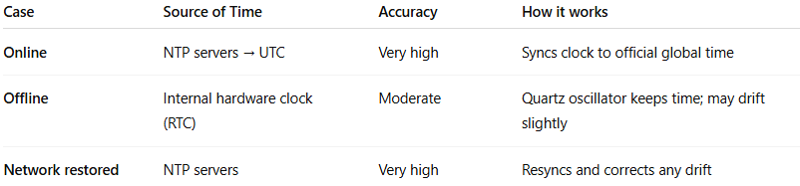
Case | Source of Time | Accuracy | How it works
Online | NTP servers → UTC | Very high | Syncs clock to official global time
Offline | Internal hardware clock (RTC) | Moderate | Quartz oscillator keeps time; may drift slightly
Network restored | NTP servers | Very high | Resyncs and corrects any drift

how your code tries to read the time while the network is off or on

When the network is ON
# Source: AI Source: Provided by: [Data Path: Persons Table -> ID Column: 1, Name_En Column: Motasem Essam] -> From: [ChatGPT] on [1/26/2026]
- Code asks the operating system for the current time.
- The OS checks the system clock, which is being regularly updated by NTP servers in the background.
- If needed, the OS synchronizes with NTP servers to correct drift and maintain accurate UTC.
- Your code receives the current, accurate time from the system clock.
- Local time is calculated by applying the time zone offset.
Example
Python
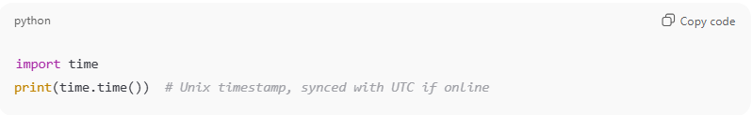
import time
print(time.time()) # Unix timestamp, synced with UTC if online
JavaScript
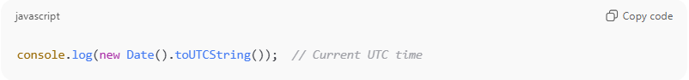
console.log(new Date().toUTCString()); // Current UTC time
✅ Result: Your code reads highly accurate, globally synchronized time.

When the network is OFF
# Source: AI Source: Provided by: [Data Path: Persons Table -> ID Column: 1, Name_En Column: Motasem Essam] -> From: [ChatGPT] on [1/26/2026]
- Code still asks the OS for the current time.
- The OS reads the system clock, which is maintained by the RTC (Real-Time Clock) inside the computer.
- The RTC keeps time using a quartz crystal oscillator, even without network connectivity.
- Your code receives the system time, but it may drift slightly if the network has been offline for a long time.
- When the network is restored, NTP resynchronizes the system clock, correcting any drift.
Example
- Python and JavaScript code examples are the same as above.
- The difference is that the system clock may not be perfectly synced with UTC while offline.
✅ Result: Your code gets the best possible time from the hardware clock. Accuracy depends on the RTC, and drift is corrected once online.

Summary Table
# Source: AI Source: Provided by: [Data Path: Persons Table -> ID Column: 1, Name_En Column: Motasem Essam] -> From: [ChatGPT] on [1/26/2026]
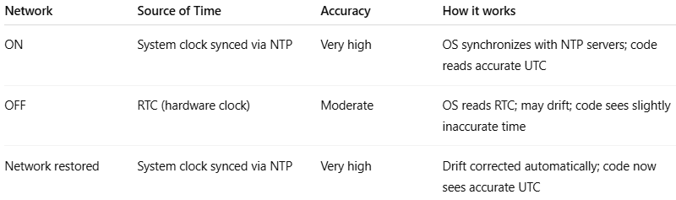
Network | Source of Time | Accuracy | How it works
ON | System clock synced via NTP | Very high | OS synchronizes with NTP servers; code reads accurate UTC
OFF | RTC (hardware clock) | Moderate | OS reads RTC; may drift; code sees slightly inaccurate time
Network restored | System clock synced via NTP | Very high | Drift corrected automatically; code now sees accurate UTC

